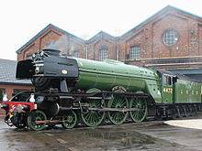



**Read all about it**

**[DK Find out](https://www.dkfindout.com/uk/transport/history-trains/)**

**[Network Rail](https://www.networkrail.co.uk/communities/safety-in-the-community/safety-education/primary-school-resources)**

**[George Stephenson](https://www.theschoolrun.com/homework-help/george-stephenson-and-the-development-of-the-railway)**

[**Isambard Kingdom Brunel**](https://www.theschoolrun.com/homework-help/isambard-kingdom-brunel)

**Music / Sound**

**Can you clap the rhythm of a steam train? Do trains now sound the same?**

**English - Isambard Kingdom Brunel**

**Find out all about this AMAZING engineering genius and create a fact file for him. Including a heading, a sub-headings, interesting facts, and a drawing of him.**

**PSHE Memory Game**

**A lot of us used to play this when going on a journey. Can you think of a word for each letter of the alphabet?**

**I unpacked my Grandmothers trunk and in it I found …an acrobat, a bathmat, carousel etc …**

**You need to start from the beginning each time remembering what everyone has added!**

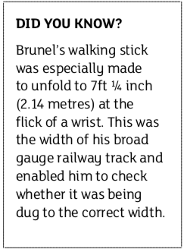

**History / ICT**

**Railways (fact file attached)**

**Can you create a fold out timeline from the first steam locomotive to present day trains?**

**Use key dates only, the name of the train and who invented it.**

**Art**

**Can you use your pencil sketching skills to sketch the Flying Scotsman?**

**Mathematics / DT / Science**

**What do you know about the Clifton Suspension Bridge?**

**Can you use junk modelling to create a suspension bridge like this?**

**Test its strength: It will need to hold 10 small cars - how will you test it?**

**How does it fair on a windy day? Does it stand up if you blow a cold hairdryer at it? (adult needed) How would you anchor it?**

**P.E.**

**Joe Wicks**

**PE**

**9am**