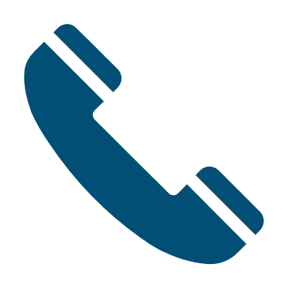

Need some advice and support to help pay your utility bills and to buy food and necessary items?

Are you facing demands from utility companies for payment of bills and are they unable to understand you don’t have a banking account that allows direct debits, you always pay by cash?

Can’t talk to your bank and feel worried that if you did get through to someone, they won’t listen to you?

The following advice may help you during this difficult time.



Citizens Advice Helpline:

Adviceline: [03444 111 444](tel:03444111444)

Website: <https://www.citizensadvice.org.uk/about-us/contact-us/contact-us/contact-us/>

<https://www.parentingsolutions.co.uk/>

Email: parentingsolutions.devon@

gmail.com

### Help is available if your cash bank account is causing you difficulties.

#### Basic Bank Account advice

How to make the most of a cash bank account.

Parenting Solutions

Parenting Solutions – advice and support to families in Devon.

Tel: 07463969245

In the UK there are nearly 8 million people with a basic bank account.

Basic bank accounts help you manage your money, some of the bigger banks will offer a debit card as part of their basic bank account package, whilst all generally offer a cash card.

Some basic accounts let you use telephone or online banking facilities.

Some cash accounts let you set up a direct debit but others won’t allow this.

The basic bank account may have worked brilliantly for you before Coronavirus (COVID-19) but now you find yourself in a difficult situation:

* Cash is not accepted at your local shop?
* You pay your utility bill at a local PayPoint shop and they will not take cash?
* Your bank account will not allow you to set up direct debit payments?
* You have a cash only card and keep being refused at the shop?

I am worried about phoning my bank

This is understandable, you can be on hold for hours waiting for a human to answer your questions. Take a look on your bank’s website, do they have an email address you can write to? Do they have a ‘pop-up’ chat facility for you to quickly ask a question? Can you log onto your account?

What if they won’t let me update my account to an account with a debit card and/or direct debit facilities?

If your only option is cash payment it is worth asking your bank to pay the bill from your account for you. A bank transfer or payment is not the same as a direct debit or standing order. If you have the sort-code, account number and use the reference number your utility company has provided you with, you can ask the bank to transfer the money for you.

I can’t get to the bank, what can I do?

Either phone or email to request setting up a phone or online banking service. Once you are set up you can access your account, set up bill payments (not direct debits) and have more control of your account.

Anything else?

Most utility companies are going to understand the issues you are having but may send out automated ‘demand’ letters. Keep these but do not feel pressured or intimidated by them. Keep your utility money safe in your account, save bank statements or advice slips to keep track of this money and make a payment as soon as it is possible for you to do so.

#### HOW CAN I PAY MY BILLS WHEN I HAVE A CASH BANK ACCOUNT?

The 10 big banking companies now offer ‘basic bank accounts’ which will give you a debit card and allow you to set up direct debits. If you have had a cash account for several years, ask your bank if you can move into their ‘newer’ basic bank account with a debit card.

You will not get an overdraft with this type of bank account. But it will let you buy things online; you can set up direct debits or bill payments for your utility companies.

What if I must stay with the cash account I already have?

Don’t panic!

The following advice can help you keep on track and answer some of your questions.

### Do you have a basic bank account?