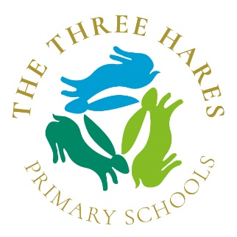
Message from Mrs Underwood
As we move towards the Bank Holiday weekend, we expect to hear an announcement from the Prime Minister about plans which will guide leaders in how to bring children back together into school. Rumours and speculation about what is going to be announced are rife so it will be interesting to hear what the announcement will include. However, return to school is likely to be phased and gradual. This is the basis on which we are developing our planning, as Three Hares Leaders.
I wanted to reassure you that we continue to be very mindful of the concerns, anxieties and nervousness that the suggestion of return may cause to many of our families and indeed our staff. I want to assure you that our paramount concern will be the safety, health and well-being of our whole school community. Since lockdown began in March, we have been talking and planning about how to return, with excellent support from the DMAT executive leads, through frequent virtual meetings and phone calls.
We will listen carefully to the government guidance delivered on Sunday, and assimilate it in to our plans for return. We are taking account and integrating guidance from a variety of sources already, not least sharing thoughts across our DMAT schools. We expect to continue developing our home-learning offer, to ensure that the needs of all children and families are met through virtual schooling. Indeed today, I have initiated a partnership with an EdTech Demonstrator Programme to develop the use of technology which will enhance the curriculum provision for our staff and teachers.
May I take this opportunity to wish you a restful and happy, long weekend and I hope you are able to enjoy some of the VE Day celebrations. We will all have to save the street parties for another day in the future! Stay safe and well.
With my very best wishes
Elizabeth Underwood

