Resource List: 3 July 2020
The School Library Service Team are back in Willand although with reduced numbers whilst social distancing is still necessary. We are not yet open to visitors but please continue to contact us by phone or email us for support with your book related queries.

We are happy to receive your topic requests for the autumn term, just submit your requests here;
https://www.babcockldp.co.uk/support-services/school-library-service/topic-boxes

Primary and Secondary

Talk for writing have released the fifth and final batch of their English workbooks. They have now produced 40 extended English units, with audio included, all available to download for free, although they do ask for a donation to Great Ormond Street if possible.
This is the link
The Scottish Book Trust have a wealth of resources including ‘Authors Live’ featuring videos of around 80 authors talking about their books and interests to an audience of children as well as a link to a ‘bookbug’ app for rhyme time to support families with young children, particularly those with English as an additional language https://www.scottishbooktrust.com/authors-live-on-demand
The Book Trust are delighted to announce that their Laureate team have been working behind the scenes for the last two weeks to build a series of online activities named Cressida Cowell’s Creativity Summer Camp.
This will run on the Children’s Laureate website between 6 – 10 July, and aims to celebrate children’s innate creativity and showcasing the enormous wealth of creative talent across the UK.
https://www.booktrust.org.uk/news-and-features/news/news-2020/creativity-has-never-been-more-important-childrens-laureate-cressida-cowell-launches-creative-summer-camp/

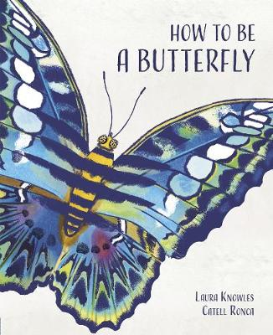The Herts for Learning blog has some lovely ideas this week including activities to use with this beautiful new book from Laura Knowles and an excellent Roald Dahl Call my Bluff game– snozzcumber anyone?

Herts Primary English teaching & learning resources for KS1 & KS2: weekly digest, vol 11

Accelerated Reader has useful resources. There is a webinar on Reading for Pleasure during school closure and Mind Travels competition for all schools not just subscribers. https://lp.capita-readingcloud.co.uk/index.php/email/emailWebview

Primary

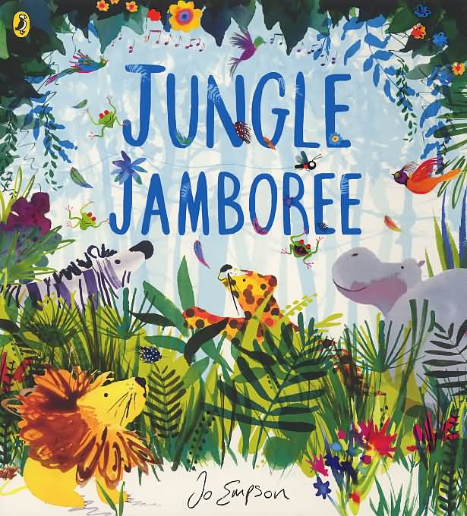The charity Children’s Bookshow websites features some lovely picture books and poetry, each with a short write up on the author, a video of the book being read aloud, some by the author themself, and some lovely follow up activities that could be done in school or at home.
https://thechildrensbookshow.com/news
This week’s book of the week is Jungle Jamboree by Jo Empson
https://mailchi.mp/3f90220ad664/eqg5i58euc-4219166

For Parents
The Good Things Foundation has formed a new coalition to offer immediate support to digitally and financially excluded people in the UK - with a focus on those in poverty hit hardest by the impact of Covid-19. The Leave Nobody in the Dark campaign highlights these issues and addresses them with practical help: personal one-to-one support, digital devices and bespoke online resources. https://www.goodthingsfoundation.org/news-and-blogs/news/leave-nobody-in-the-dark

Libraries
Libraries Connected publishes its toolkit to help public libraries to reopen in July and to reintroduce their services gradually, in line with the latest public health advice. Some useful tips for school libraries. http://www.librariesconnected.org.uk/news/new-guide-help-libraries-reopen

