Ukraine Appeal
Little Bags For Children
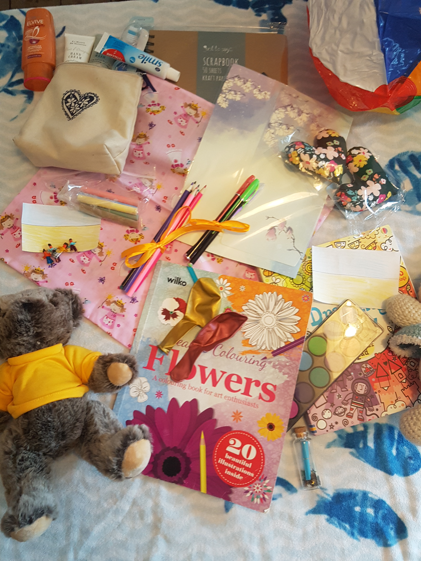
We are planning to send 300 “Little Bags for children” to Ukraine to support children fleeing from the conflict.

Each “Little Bag” contains a number of creative activities and all the resources to complete them designed to support children who have experienced loss or separation.

You can help by donating the following items to go in the bags

Crayons
Chalks
Coloured Pens
Coloured Pencils
Colouring pads
Pencil sharpener
Eraser
Soft toy (no bigger than 30cm)
Writing paper and envelopes (ideally nicely patterned)
Draw string bags, both handmade 30cm x30cm or PE type drawstring satchels
Tooth paste (junior)
Junior Tooth brush
Small ball

Items should be new or unopened where possible the exception being Soft toys which can be pre- loved as we know some children want to make a very personal donation themselves.

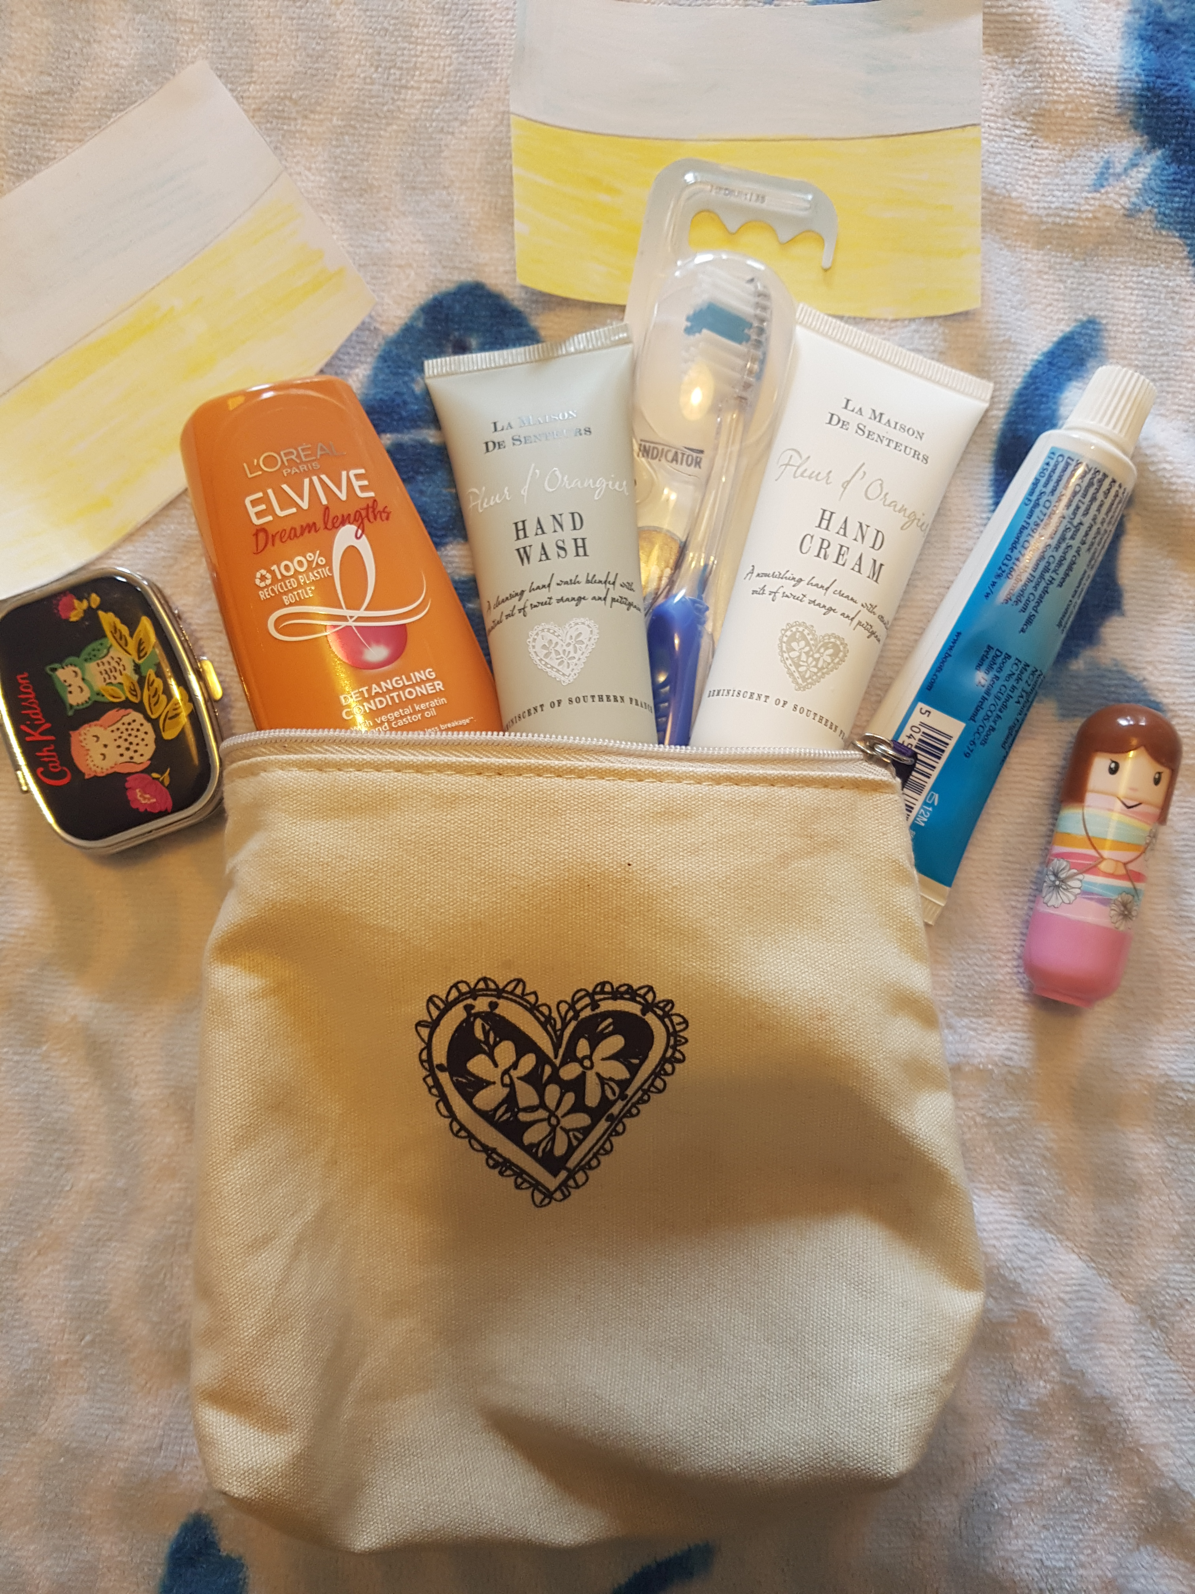
We also want to put a Gift in each bag that the refugee children can give to their parent, often their mother who has accompanied them.

For the mums/parents
Soap,
Face Cloth
Mini Shampoo
Mini conditioner
Mini deodorant
Lip Balm
Hand cream
Small wash bags to hold these items.

THANK YOU, Leif and Mary Tarry

