**LO: Different Sentence Starters**

Watch the Titanium video again.

<http://www.youtube.com/watch?v=JRfuAukYTKg&ob=av2e>

1. Choose one of sheets below. How many different sentence starters can you create? **I have provided you with some ideas to start you off.**
2. Now how can you improve my sentence?

***“The boy rode his bike away.” OR “The boy looked up.”***

1. Finally, generate different ideas about your picture and create a mind map. Select your favourite idea and write a paragraph describing how the boy gets away from the police.

Starting sentences in different ways

**When?**

Just at that moment,

Suddenly,

After what felt like forever,

**Where?**

Inside the school,

In the destroyed corridor,

**Emotion word:**

Devastated,

Confused,

Angry.

Scared,

**How?**

Gingerly,

Carefully,

Silently,

Tell:

I was frightened: my body shook, my fingers trembled and my heart hammered in my chest.

**Start with a simile….**

Like a volcano had erupted,

Like a whirlwind,

Like a flash of lightening,

**Start with a conjunction:**

When, if, before, as etc.



I stared at the devastation….

Starting sentences in different ways

**When?**

Just at that moment,

Suddenly,

After what felt like forever,

,

**Where?**

In the forest,

Upon the leafy ground,

**How?**

Rapidly,

Warily,

Silently,

**Emotion word**:

Devastated,

Confused,

Angry.

Scared,

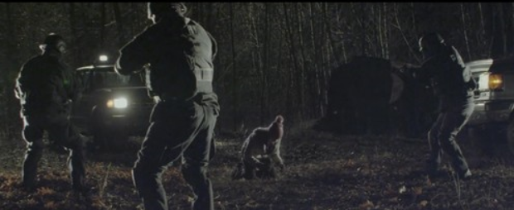

I stared at the devastation….

**Tell:**

I was trapped: I fell to my knees, covered my head with my hands and felt the power begin to well inside me.

**Start with a simile….**

Like a volcano had erupted,

Like a whirlwind,

Like a flash of lightening,

**Start with a conjunction:**

When, if, before, as etc.