Crazy Competitions

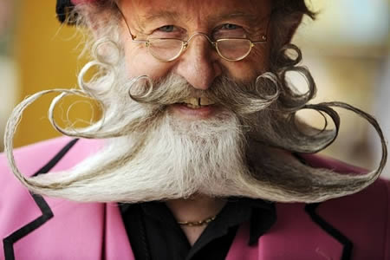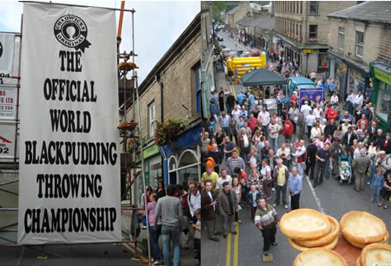
Follow these steps:
- Pick one of these competitions;
- Discuss your ideas for the rules and ways to win;
- Note down any ideas that you have;
- Pick the best ideas; and
- Create a rules and guidelines page, punctuating as you have been shown.

World Beard and Moustache Championships The World Black Pudding Throwing Championship

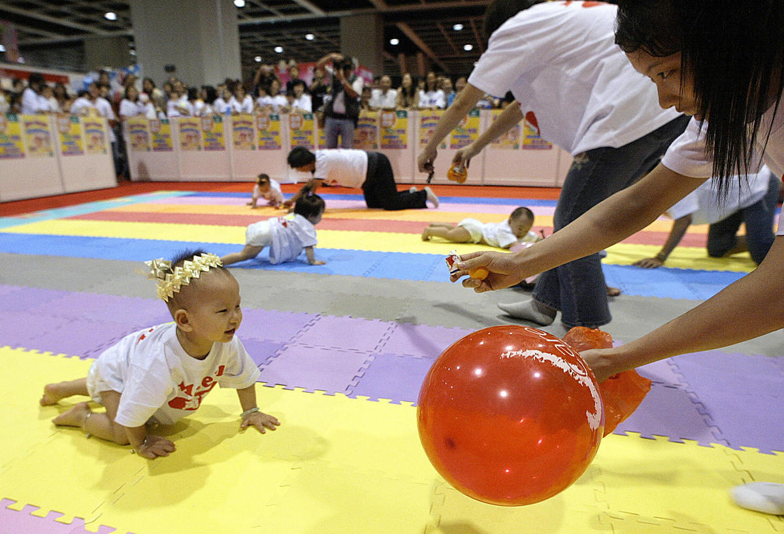

The World Custard Pie Championship Baby Crawling Contest

