Spellings

We have been looking at these this week, please practice spelling them (speed write: how many times can you write it correctly in 30 seconds) and then pop them into a crazy sentence.
-sure
measure
treasure
pleasure
enclosure
creature

-ture
furniture
picture
nature
adventure

1

2

3

4

5

6

7

8

9

Maths - Place Value recap

Please represent the following numbers using a place value chart

8261 9804 2016 4387 1450

Thousands | Hundreds | Tens | Ones

Number line recap: Take special care looking at what the line is going up in please.
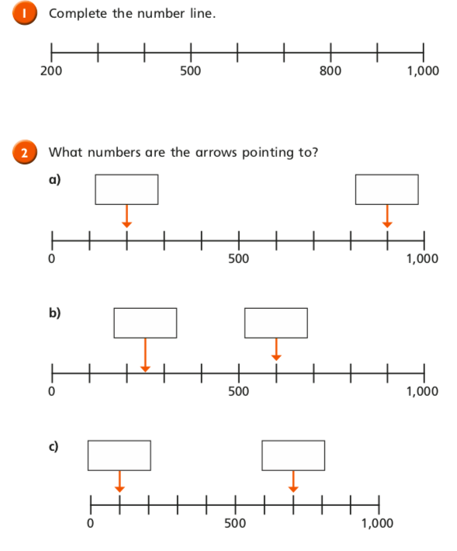

Optional Extra:
Our Science topic is Electricity, what items around the home are powered by electricity? Please list what you find for us to discuss.

