Lesson 1 – Tinkering
(Adapted from Barefoot Computing’s teaching resources. See the full lesson plan at https://www.barefootcomputing.org/resources/bee-bots-tinkering-activity)
Before starting: Print the command cards, the picture of the Beebot (this is called a ‘fakebot’) and a selection of toys. Make a space and spread out the toys. Place the fakebot next to one of these toys.
No printer? The command cards and fakebot can be drawn on paper and cut out.
Notes for adults: This activity introduces the fakebot (a printed or drawn Beebot). It allows your child/ren to explore through play what something can or cannot do. This is known as tinkering. Tinkering is an important skill when learning about computers; it means having a play to find out how it works, what it does, and how you can use it. Your child/ren will be placing the command cards into sequences for the fakebot to follow. This sequence of commands (or rules, instructions, steps) is referred to as an algorithm.
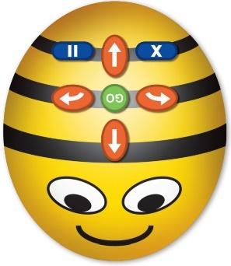
They might have used a Beebot in school. It is a programmable device that consists of only five main programming language commands:
• Forward 150mm
• Backward 150mm
• Right 90 degrees
• Left 90 degrees
• Pause for 1 second and make a tick sound;
Plus, two device control commands:
• Clear and
• go - executes commands and makes a sound when complete
Although the fakebot is not programmable, it can still be physically moved, Forward, Backward, Right and Left. You can make it Pause for 1 second by holding it in place. The fakebot will not retain any previous commands inputted therefore we just need to remind children that to start, we need to say ‘clear’ (and pretend we are clearing it of any old instructions) and when we’ve put all the instructions into the right order, we say ‘go’.
Main task – Tinkering with a fakebot:
- Explain that people are often making new things in computing, and so we need to be able to learn how to find out about these new things. Ask your child/ren about new computer-based things they have heard of or used. Make a list of these things e.g. new mobile phones, new computer games, new TVs.
- Ask how we found out how these things work. Ask what rules there might be about using new things e.g. not breaking things, asking a grown up if you can use new things etc
- Show your child/ren the fakebot and command cards and ask them what they think you could do with these.
- Lead the discussion round to tinkering – show a selection of the command cards and ask your child/ren to move the fakebot, following the sequence of commands. Where does the fakebot move to?
- Introduce the toys (these need to be spread out) and ask your child/ren to put the command cards in the correct order that will make the fakebot travel from one toy to another.
- Change the starting position and challenge your child/ren to make new sequences of command cards.
- Discuss any changes your child/ren needed to make to their sequence of commands. These changes are called debugging and children need encouraging to persevere when fixing any errors. Point out that being able to debug is a really valuable tool for life when we’re solving problems. These opportunities to debug are often when the most learning takes place.
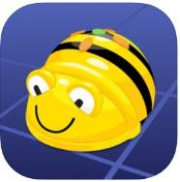
Beebot App and websites for tinkering with Beebots:
Download the Beebot app (Age: 4+) onto your phone or tablet for FREE. Search for Bee-Bot TTS Ltd
This website https://www.terrapinlogo.com/emu/beebot.html is also useful for practicing programming with the Bee-Bot.

