Lesson 4 – Create your own fakebot world
(Adapted from Barefoot Computing’s teaching resources. See the full lesson plans and resources at https://www.barefootcomputing.org/resources/bee-bots-1-2-3-programming, https://www.barefootcomputing.org/resources/bee-bots-tinkering-activity and https://www.barefootcomputing.org/resources/bee-bots-basics-activity
Before starting: Print the command cards, fakebot, challenge word cards and a set of pictures for your fakebot mat. There are many choices of themes. Some examples are: Under the Sea, Pirate Island or The Gingerbread Man theme. You will also need to be able to view or print the Non-Mat Challenges worksheet.
No printer? The command cards, fakebot and the challenge word cards can all be drawn onto paper. A Bee-Bot mat will have 15cm x 15cm squares so many resources are created matching these measurements. A mat could be created by:
- marking a grid onto a large sheet of paper with a pen
- creating a grid with masking tape on the floor
- use chalk to draw a grid outside.
Notes for adults: This activity continues to use a fakebot and brings together the vocabulary and skills from the last three lessons.
Activity 1:
- Use the Non-Mat Challenges worksheet to set a fakebot task for your child/ren.
Example task from this worksheet:
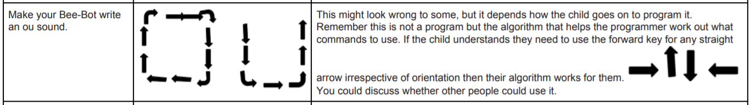
This is a great way to link their computing learning to other subjects.
Activity 2:
- Create a large grid for the fakebot to travel around and add pictures of your choice to create a themed mat.
The mat could be made by:
- marking a grid onto a large sheet of paper with a pen
- sticking masking tape on the floor
- using chalk to draw a grid outside.

- Set challenges for your child/ren to make the fakebot travel to specific spots on the grid (fakebot mat).
- Use the challenge word cards, such as ‘pause on’, ‘spin on’, ‘avoid’, ‘shortest route’, ‘longest route’ to create obstacles for the fakebot.
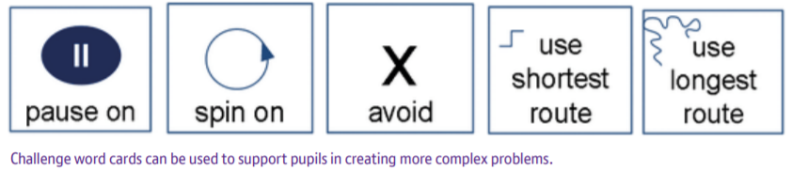

Web resources for printable 15cm x 15cm mats
http://www.communication4all.co.uk/http/beebot.htm
http://www.tes.co.uk/teaching-resource/2D-Shapes-Bee-Bot-Mats-6292208/

