Merryn and Albany’s Butterfly Quiz

- Were there butterflies in prehistoric times?

- How many species of butterflies are there in the UK? How many of these are resident, how many are migrant?

- What species of butterflies have become extinct in the last 150 years?

- How do you say “butterfly” in French?

- Are there any poisonous butterflies?

- How many wings do butterflies have?

- What pattern of movement do the wings make when the butterfly is flying?

- Do caterpillars have teeth?

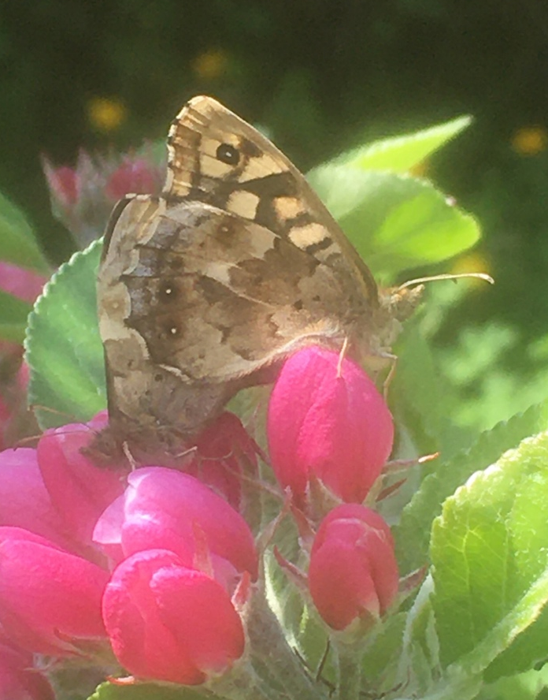
- Do caterpillars drink water?

- Is the butterfly’s heart in its thorax (chest) and it’s brain in its head?

- How do male butterflies attract female butterflies?

- How do butterfly eggs get fertilised?

