Maths: Thursday 19th March – Year 3 MONEY Lesson 2
Intro: Place value recap (hundreds, tens and ones)
Discuss: 100p = £1
Therefore 200p = £2 so what would 230p be? How else could this shown? Eg £2.30
What is the decimal place? Discuss / Elicite knowledge

Task 1:
Please show workings:
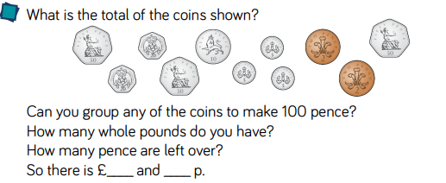

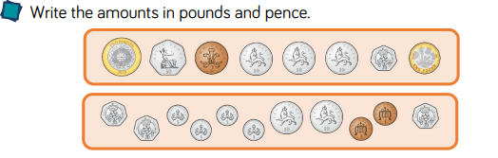
Task2) – show workings!

Task 3) (dividing by 100 to get £ - reminder)
Write number sentence and word form for number:
E.g: 165: 100p +65p= £1.65
One hundred and sixty five pence
One pound sixty five
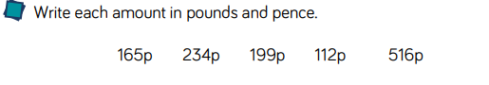
CHALLENGE!
Dive Deeper -Tricky challenges! Show your workings please:
