Year 3 - Maths - Wednesday 18th March –
Home learning copy Money

- Introduction: Talk it. Resources needed – money –variety of coins and notes

Record what the child says for reference later on.
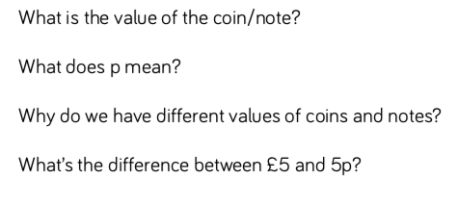

- Discuss what the word equal means – draw a line with a ruler to the corresponding amounts.
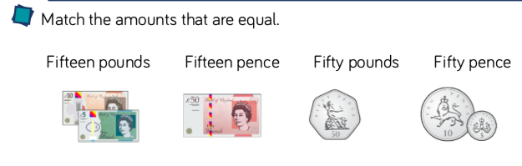
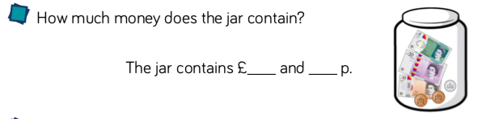

- Take a careful look in the jar – which notes can you identify and how much money is in there?

- Discuss the meaning of greater than and less than
(remembering the crocodiles open mouth eats the larger number , so faces the larger number with jaws open)

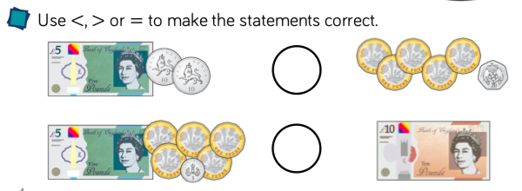

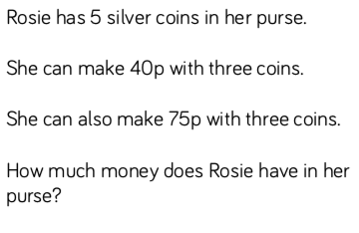
- Dive Deeper – challenge – remember to draw it and show your workings out please.

