Resource List: 10 July 2020
We are not yet open to visitors but please continue to contact us by phone or email us for support with your book related queries. We are happy to receive your topic requests for the autumn term, just submit your requests here:
https://www.babcockldp.co.uk/support-services/school-library-service/topic-boxes

Our bookmark competition attracted lots of wonderful entries but after careful deliberation we are pleased to announce that the winners are Lucy from Thorverton and Frankie from Ugborough.
(see separately attached poster)
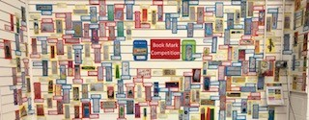

Babcock School Library Service are going to be supporting Reading Together Day on Thursday 16th July (see below). Watch out for us in action on Facebook and Twitter.

Primary and Secondary Resources
Over 15 organisations across books, publishing and education sectors have collaborated to create a family friendly schedule of events for ‘Reading Together Day’ on July 16th to highlight the importance of reading together.
https://readingagency.org.uk/news/media/reading-together-day-announced-for-16-july-2020.html
Children’s books roundup – the best new picture books and novels -a selection from Imogen Russell Williams for the Guardian.
https://www.theguardian.com/books/2020/jun/27/childrens-books-roundup-the-best-new-picture-books-and-novels

Life in lockdown has been a challenge for us all. The Children’s Literature Festival want to hear about your experience in a poetic style of your choice. You can write your poem on any subject that you associate with being in lockdown. Entry Age 7-16
£100 book tokens
An author visit to your school
Closes 30th August
https://www.childrensliteraturefestivals.com/my-lockdown-poem/

Chicken House have an aptly named page of story sessions with some fantastic authors.
https://www.chickenhousebooks.com/schools/coopedupkids/

This week the winners of the Henrietta Branford Writing Competition were announced and the range and quality of the stories written by the young authors is impressive.
https://branfordboaseaward.org.uk/hbwc-2020-winners/

Head teacher Simon Smith shares some picture “books that work phenomenally well in year 6. They are mature, thoughtful, complex and challenging as all the best books are”.
https://smithsmm.wordpress.com/2020/06/28/more-picturebooks-for-year-6-list-2-picturebookpage/

Book Trust’s author of the week is Alex T Smith and there is a lovely 7 minute tutorial from Alex showing you how to draw Claude, a free download of his book Best In Show and printable activity sheets.
https://literacytrust.org.uk/family-zone/5-8/get-free-claude-book-alex-t-smith/
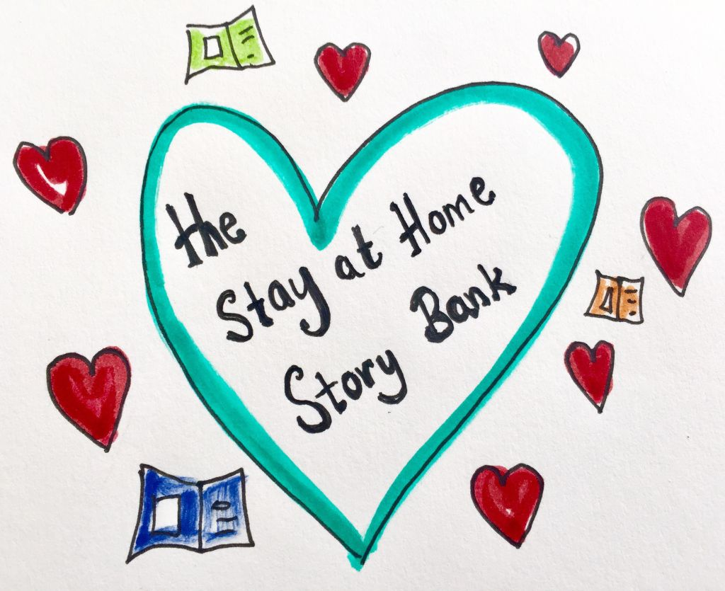
Wendy Meddour can be watched here along with a range of other authors reading their books including Oliver Jeffers, Chitra Soundar, Claire Barker, Sarah Mcintyre and more.
https://wendymeddour.co.uk/the-stay-at-home-story-bank/

Bounce Back 2 – supporting children returning to school. This is an extremely useful article on the Just Imagine blog suggesting books on different themes such as friendship and kindness, cherishing our world and community and real-life heroes, topics that may be helpful for the next academic year.
https://justimagine.co.uk/2020/06/28/bounce-back-2-supporting-children-returning-to-school/

COVID-19
As constriction to daily routines and social lives drags on and we hear how children’s mental health is suffering we may be needing to direct parents to the available help. This free NHS backed app is aimed at supporting parents and children through fun activities and interactions to develop positive mental health, resilience and self-esteem, helpful now and useful generally
https://myhappymind.kartra.com/page/light-enquiry

Lockdown has been very challenging for families and has limited many children’s access to education. To help all children have access to books and the life-changing benefits that reading brings, BookTrust has created a range of care packages which are being given out in local communities. Grouped into different age groups, community partners can select packages for early years, primary or secondary aged children.
https://www.booktrust.org.uk/what-we-do/programmes-and-campaigns/care-packages/

