Learning Objective: I can identify what materials different items are made of.

**These items are made of metal:**

**These items are made of wood:**

**These items are made of glass:**

**These items are made of plastic:**

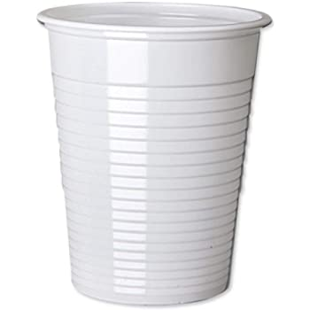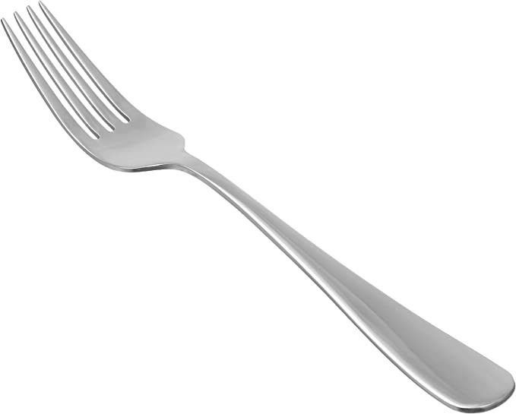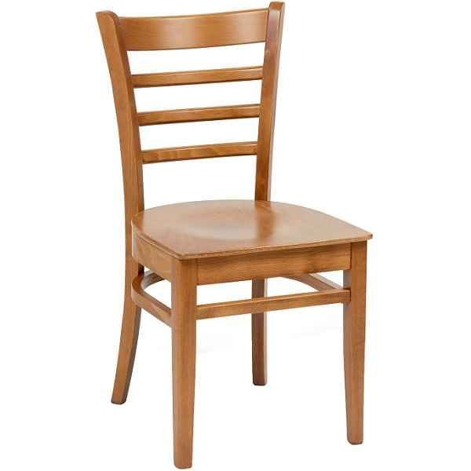

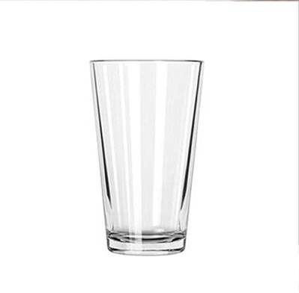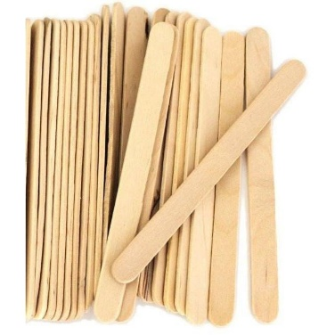

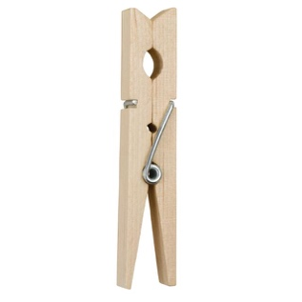

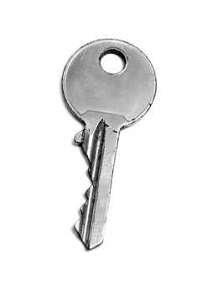

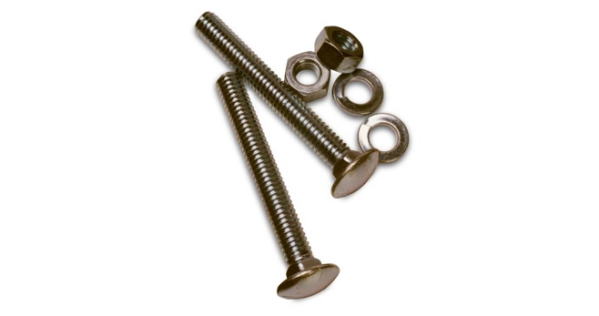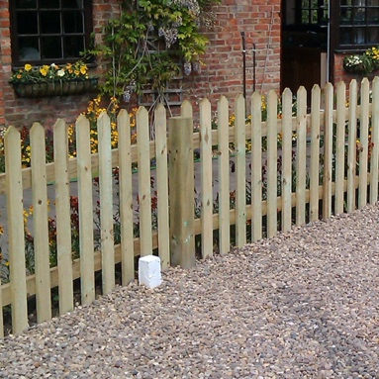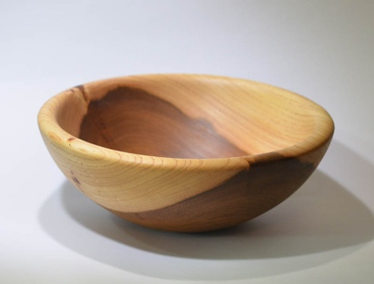

**Clothes peg**

**Wooden chair**

**Key**

**Glass**

**Window**

**Cup**

**Lollipop Sticks**

**Nuts and bolts**

**Fork**

**Chain**

**Fence**

**Wooden Bowl**