Thursday 19th March

To be able to ‘map’ Archie's feelings in Chapter 2

Plot Archie’s feelings as you move through the events in Chapter 2.

Using yesterday’s story map (or finishing off then start this activity), think about how you would feel in that situation. Think about a feeling and say why you would be feeling it. Maybe draw on a personal experience?

What clues are there to show how he feels? Annotate your own graph with some of these. Use the emotions thesaurus attached to help.

A peak to show happy maybe, a dip to show sadness / confusion?

Ideas:
1) Archie on errand for mum to get milk: I think Archie would be happy getting out of the house because it’s a lovely day. He might be thinking about yesterday’s crazy events and laugh to himself!? This would be a high point!
2) Archie sees dog: I think Archie would feel shock at seeing the dog etc… I once saw a hedgehog on the road and it wasn’t moving! I wanted to touch it but felt anxious because … This would be a midpoint for me as I’m curious!
3)
4) …..
The graph could look something like this:
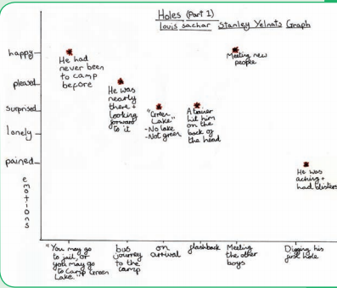

]

Extension: Use dictionaries to explore meanings of unknown feelings on the thesaurus chart. Use them in exciting sentences to demonstrate you know what they mean – this can run on into Friday.

